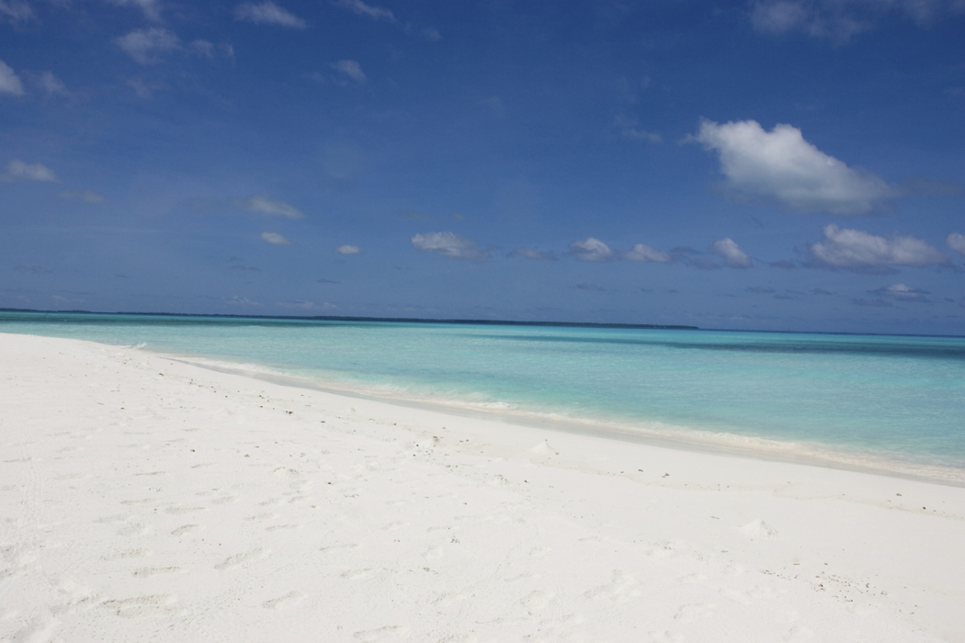





*Funds to benefit the Monmouth Beach 8th Grade Class of 2018*

**Date:** Friday, August 18th, 6pm – Saturday, August 19th, 9am

**Rain date:** *Friday, August 25th*

**Place:** Monmouth Beach Bathing Pavilion (“Little Monmouth”)

**Cost:** $40 per family/tent

**Registration Forms available at Pavilion and Boro Hall**

*Event opened to Bathing Pavilion Members & Monmouth Beach School*

***Schedule***

**6 -7:30 pm** **(August 18th ):**  Registration/tent set-up

* + 8th graders will help unload cars and setup tents

Ocean swimming till 8

**6 – 9 pm:** Baked goods for sale

**8 – 11pm:** DJ and Bonfire on the beach

**9 – 10 pm:** Italian Ices for sale

**1:30 am:** Quiet-time

**6 am (August 19th)** Sunrise & breakfast will be available to purchase

**9 am:** Tents down and beach departure

* + 8th graders will help load cars

**NOTE:** All participants must comply with Beach Pavilion rules & family-camp regulations:

1. No alcoholic beverages permitted.

2. Swimming restricted to lifeguarded area, and permitted only during swim times noted above.

3. The family person-in-charge resumes full responsibility for his/her registered participants.

4. One parent per 4 children required to ensure proper supervision. *All participants under 18 years old must be registered with an adult.*

5. Tents limited to 6 participants - please be courteous and mindful of limited beach space when considering tent size.)

“Family Camp on-the-Beach” Registration Form TENT #_________

Family person in charge: ________________________ # of total participants: ______ # of tents: ______

Address: ______________________________________________________

Phone #: __________________ Cell phone #:___________________Email ID:____________________

Are you a member of the Monmouth Beach Bathing Pavilion? Yes or No

Do you have a child/children attending Monmouth Beach Elementary School? Yes or No

Names of each participant & age

1. ______________________________ Adult

2. ______________________________ Adult

3. ______________________________ age: ____ Family member __________or guest__________

4. ______________________________ age: ____Family member __________or guest__________

5. ______________________________ age: ____ Family member __________or guest__________

6. ______________________________ age: ____ Family member __________or guest__________

For all non-family participants, permission must be assigned as follows:

I give permission for my son/daughter _______________________ to attend the “Family Camp on-the-beach” August 18-19, 2017 (rain date August 25-26, 2017) with ___________________________.

Parent/Guardian Name: _____________________________________________________

Print & Sign Date__________________________________________

Contact Info: Home Phone: ____________________Cell phone #: _________________

Other Emergency Contact: _____________________Phone #: _____________________

I give permission for my son/daughter _______________________ to attend the “Family Camp on-the-beach” August 18-19, 2017 (rain date August 25-26, 2017) with ___________________________.

Parent/Guardian Name: _____________________________________________________

Print & Sign Date__________________________________________

Contact Info: Home Phone: ____________________Cell phone #: _________________

Other Emergency Contact: _____________________ Phone #: _____________________

I give permission for my son/daughter _______________________ to attend the “Family Camp on-the-beach” August 18-19, 2017 (rain date August 25-26, 2017) with ___________________________.

Parent/Guardian Name: _____________________________________________________

Print & Sign Date__________________________________________

Contact Info: Home Phone: ____________________Cell phone #: _________________

Other Emergency Contact: _____________________ Phone #: _____________________

**Acknowledgement:**

As “Family Person-in-charge,” I resume full responsibility for my registered participants. I fully understand and will abide by the Beach Pavilion rules, Family camp-schedule (6-7:30 pm registration Fri, 11:30pm quiet time, 9am beach departure Sat), and the following regulations:

1. No alcoholic beverages permitted.

2. Swimming restricted to lifeguarded areas only with presence of on-duty lifeguards

3. One parent per 4 children required for participation.

*All participants under 18 years old must be registered with an adult.*

4. Tents limited to 6 participants.

I understand compliance with the above is essential to ensure a very fun, safe, and memorable *Monmouth Beach family camp on-the-beach experience*! Non-compliance will result in dismissal without refund.

Family Person-in-charge: ____________________________________________

Print & Sign Date ____________________

Cost: $40 per family per tent

Please send form & payment (checks payable to: *Monmouth Beach School/ Class of 2018)* to: 7 Hastings Place, Monmouth Beach, NJ 07750

Or drop off at the Beach Club Front-desk

Please contact Mary Mazzacco with questions.